Auckland Transport – train travel logger project

- Created ‘auckland_transport_db’
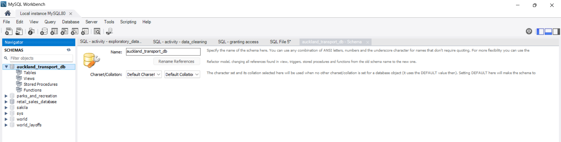
- Created the tables based from the AT CSV data

